**Information**

|  |  |  |
| --- | --- | --- |
| **CRIM ID** | **Title** | **Workstream** |
| C0037 | Load Forecast into IFS MPS | Forecasting (Supply Chain) |

**Revision History**

|  |  |  |  |
| --- | --- | --- | --- |
| **Revision** | **Date** | **By** | **Remarks** |
| 0.1 | 11/01/2021 | Jennifer Anderson | Base spec |
| 1.0 | 8/2/2021 | Jen Anderson | Updates after discussion with Kevin Douglas |
|  |  |  |  |
|  |  |  |  |

# CRIM Narrative

Tunstall requires a procedure to load XLS forecast files that are created each month by the regions, to feed into the Forecast 0 column within the MPS screen in IFS.

The Purchasing Manager will need a way of taking the existing forecast files and loading the forecasts into IFS. The flat file will be created outside of IFS and will be picked up by a custom event and loaded in as rows for the different sites (2012 for UK Commercial and 2011 for all other regions).

The target table should be date/time stamped to see who loaded the file, what was loaded and when. This would enable looking back to see historical data loads and should not be editable.

A task will then be run to load the data into the Forecast 0 column on a part by part basis.

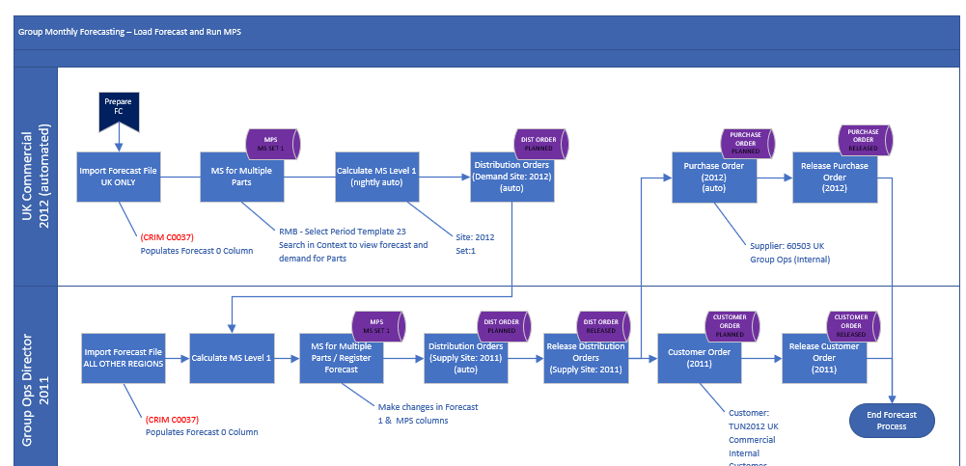

This CRIM will cover the key steps:

1. Extract the data out of the consolidated file spreadsheet (CSV) saved to a shared file location – there will be one file for 2012 (UK Commercial) and one file for all other regions (loaded in to 2011)
2. Set up a migration job to load the data into the “Forecast 0” column for the dates specified in the file (i.e. last Friday of the month), by site. This will be run as a monthly scheduled migration job, on a day/time specified by the user.

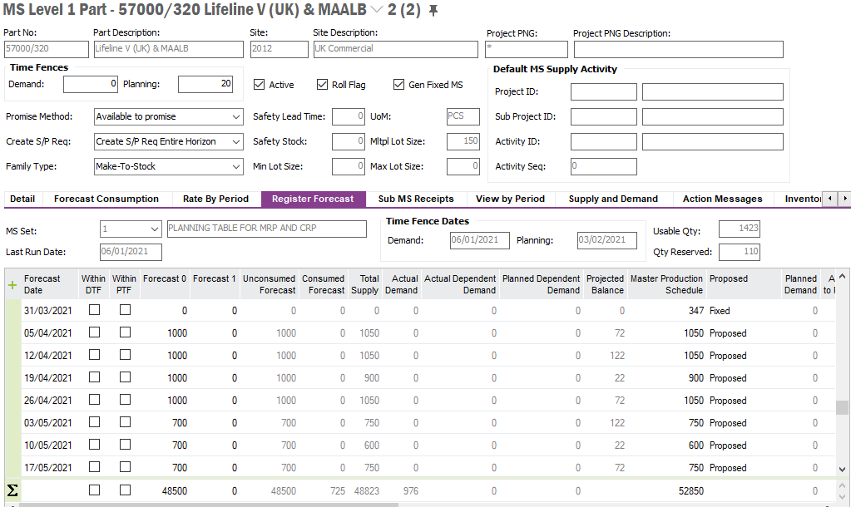

Please see below a mockup of the CSV file to be loaded into IFS:



# Technical Proposal

# Technical Solution

## Technical Process

***********************************************

## Report Components

********************************************

## Known Dependencies

*\*\*\*\* Guidance Notes – Remove prior to submission \*\*\*\**

***********************************************

# Deployment Instructions

*\*\*\*\* Guidance Notes – Remove prior to submission \*\*\*\**

***********************************************

# Developer Test Proposal

*\*\*\*\* Guidance Notes – Remove prior to submission \*\*\*\**

* *Tests recommended by the developer to be included in UAT*

*e.g.*

| **Test ID** | **Recommended Test** |
| --- | --- |
| 1 | Test the boundaries of all parameters |
| 2 |  |
| 3 |  |
| 4 |  |
| 5 |  |
| 6 |  |
| 7 |  |

***********************************************

# User Acceptance Tests

***********************************************

# DELIVERY NOTES

***********************************************

* Migration Jobs

1. LEVEL_1_FORECAST_FILE

1. LEVEL_1_FORECAST_MIG

Firstly, the excel document needs to be loaded via the 1st migration job (LEVEL_1_FORECAST_FILE) , then the second should be executed (LEVEL_1_FORECAST_MIG) .

* Permission Grants applied – IFS_ALL.